Latest Round-ups:
Season 2019/20
#23
Premier Division: Bradford Town maintained their three-point lead at the top of the Premier Division following a comfortable 4-0 victory over strugglers Odd Down. Surprisingly, the game was goalless at the interval, with Tyson Pollard seeing his spot-kick at the end of the half saved by the visiting keeper. The Bobcats didn’t take long to make amends however, and soon after the interval they went in front, when Charlie Walton scored his first for the club. A double from leading scorer Gary Higdon then put the result beyond doubt, with Kieran Baggs adding a late fourth. Plymouth Parkway kept up the pressure on Bradford, surviving a penalty miss of their own on the way to a 3-1 victory at home to Brislington. Having taken a 13th minute lead thanks to an Aaron Bentley header, Parkway found themselves level when Neikell Plummer converted a Simon Prangley cross for the visitors. Jordan Copp saw his penalty saved by Ben Payter early in the second half, but that didn’t derail the Plymouth outfit, who pushed on to take all three points thanks to a goalscoring double from top scorer Adam Carter. Another side hot on the tails of Bradford are Exmouth, and they collected a fourth consecutive win, after goals in either half from Callum Shipton helped them beat Bitton by two goals to nil. Fourth-placed Hallen defeated Cadbury Heath 5-0, with former Heathen frontman Sacha Tong coming back to haunt his former side after plundering a hat-trick. Tong’s first goal of the afternoon came at the end of the first half, doubling Hallen’s lead after Aron Robbins had put them ahead on the half hour. Robbins then struck again ten minutes into the second half, before Tong scored twice more during the final quarter to wrap up the convincing home victory. In another one-sided affair, Shepton Mallet’s six second-half goals saw them ease to a 6-0 win at home to Chipping Sodbury Town. After drawing a blank during the first 45, Mallet took no time at all in taking control of the game after the break, with Joe Morgan and Jack Fillingham each scoring soon after the restart. Fillingham then teed up Morgan to make it 3-0, before Morgan turned provider for Daryl Charman who continued the romp, adding the home side’s fourth of the afternoon. A Fillingham penalty took the hosts further clear, before a stoppage time effort from Tyrone Tucker-Davis completed the rout. Buckland Athletic came out on top following an entertaining game away at Clevedon Town, scoring a last-minute winner to cap a 3-2 victory. After Lloyd Gardner had given Buckland a 31st minute lead, Archie Ferris turned the game on its head, scoring twice in the space of ten minutes to put Clevedon in front at the break. The talismanic Richard Groves drew Buckland level early in the second half, and then with a draw looking most likely, Nathan Cooper’s through ball found its way to Will Hancox who tucked the ball home to hand the Bucks all three points.
There was also a dramatic 3-2 victory for Bridgwater, who had to overturn a half-time deficit to see off 18th placed Bridport at Fairfax Park. Having gone ahead from the spot through Jake Llewellyn, Bridgwater were stunned by their visitors, who scored twice in the space of five minutes through Will Gape and Declan Cornish to lead at the interval. Sam Towler turned out to be Town’s saviour, and after drawing the home side level ten minutes into the second half, he then converted a Jake Brown cut-back late on to complete the comeback. Goals in either half from Jordan Annear saw Tavistock beat Keynsham Town 2-1, while efforts from Leighton Thomas and Henry Lawrence-Napier helped Street come from two-down at the interval to draw 2-2 with Roman Glass St George. In Somerset, two first half penalties from Callum Demkiv helped Westbury United claim a 3-1 victory over Wellington. Having fallen two goals behind, Charlie Dodd gave Wellington a glimmer of hope when he halved the deficit 20 minutes from time, before two-goal hero Demkiv passed the ball to Joe Stradling who tucked home a third for Westbury in the closing stages.
Players from Tavistock and Keynsham challenge for possession during their clash at Langsford Park.
First Division: In an incredible start to 2020, First Division leaders Longwell Green Sports came from 4-2 down at the break to defeat Bristol Telephones 5-4. Longwell Green had only suffered four defeats in the first half of the campaign, but it looked like they would begin the new year on the losing side after Dhani Golding scored four times for the rampant visitors. The hosts had other ideas however, and managed to pull off a comeback for the ages. As well as an own goal, Longwell Green had four different scorers, with Tom Welling, Kyle Box, Liam Oswin and Sam Crumb each finding the back of the net at Shellards Road. Three goals in the final 20 minutes saw Wells City storm to a 5-1 victory at home to Sherborne Town. The game was level at the break after Josh Williams equalised for the Zebras to cancel out Craig Herrod’s 11th minute opener. Herrod’s second of the contest restored Wells’ advantage ten minutes into the second half, before a headed effort from Harvey Hadrill put the home side 3-1 ahead. Harry Foster then wrapped up the victory, scoring twice in the closing stages to add to his increasing tally of goals in what has been an impressive season for the striker. Bishops Lydeard forward Jake Quick went one better than Foster, scoring a treble during Bishops Lydeard’s 4-1 victory at home to Welton Rovers. After lobbing the keeper from a tight angle in the 18th minute, Quick then struck again at the end of the first half to double Lydeard’s half-time lead. Man-of-the-match Quick made it 3-0 20 minutes from time, with Lewis Coleman then pulling a goal back from long range for the visitors, before a wonder strike from Mark Clunie rounded out Lydeard’s first home victory since mid-September.
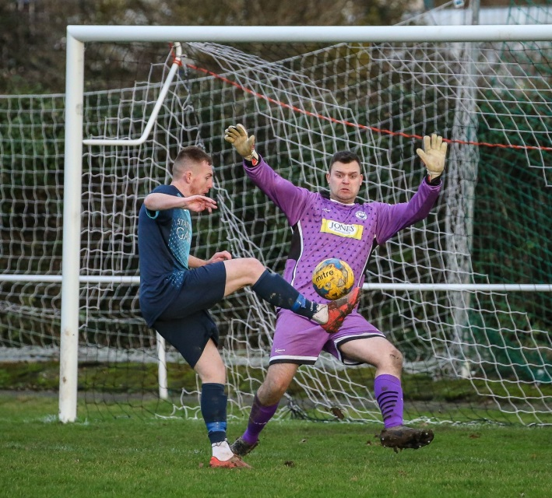
Radstock Town are up to fourth, after goals from James Rustell and Morgan Skipp helped them win 2-1 away at Warminster, with James Vincent striking for the home side during a level first half. Another side to win away from home were Corsham Town, with goals in either half from Josh Bright and Luke Curtis leading them to a 2-0 victory over Portishead. In the day’s early kickoff at Nursteed Road, Almondsbury salvaged a point away at Devizes Town. Oscar Webster’s 12th minute effort looked set to gift the Wiltshire side all three points, but the away side managed to grab a share when Keelan Mastouras produced a perfect chipped finish with ten minutes left on the clock. Ashton & Backwell United have now won three games on the bounce after coming from behind to beat Lebeq United 3-2. The Stags trailed on two separate occasions at Oaklands Park, but took all three points thanks to goals from James White, Jacob Spence and Connor Saunders. Hengrove Athletic have now won three of their last four games by one goal to nil, after an injury time winner saw them beat promotion-chasing Cheddar at Paprika Park. In a repeat of the reverse fixture during October, Hengrove left it late before snatching victory, with a brilliant finish from Peter Sheppard cannoning in off the crossbar to help the home side rise to 16th in the table. Bishop Sutton ended a run of nine matches without victory by beating Oldland Abbotonians 3-1, scoring twice in the final 15 minutes to give them a perfect start in 2020.
Action from Corsham Town’s 2-0 victory away at Portishead, courtesy of John Cuthbertson.
Cup Action: Calne Town booked their spot in the semi-final of the Wiltshire Senior Cup, coming through a penalty shootout to beat Trowbridge. Having gone ahead from the spot during normal time through Jamal Chevolleau, Calne conceded midway through the second half, before two saves during the shootout from Sam Thomson saw them progress to the final four.
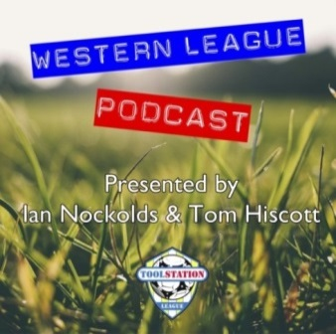

Be sure to check out the latest podcast, where Ian, Tom & guests recap all the latest news and results from around the Western League. To follow along all season, each broadcast will be available at the following link: http://www.toolstationleague.com/podcasts.php

Western League Statistical Leaders

PREMIER DIVISION LEADING GOAL SCORERS (League only):
Adam Carter (Plymouth Parkway) – 24
Jordan Harris (Exmouth Town) – 15
Jack Fillingham (Shepton Mallet) – 15
Leighton Thomas (Street) – 14
Lucas Vowles (Clevedon Town) – 13
Neikell Plummer (Bradford & Brislington) - 13
Gary Higdon (Bradford Town) – 13

PREMIER DIVISION TOP ATTENDANCES:
Plymouth Parkway 2 Tavistock 3, Thursday 26th December 2019 - 564
Bridport 0 Bridgwater Town 6, Sunday 6th October 2019 – 347
Wellington 0 Exmouth Town 2, Sunday 6th October 2019 - 315

FIRST DIVISION LEADING GOAL SCORERS (League only):
James Rustell (Radstock Town) – 18
Harry Foster (Wells City) – 17
Stuart Windsor (Calne Town) – 12
Alex Murphy (Sherborne Town) – 11
Dhani Golding (Bristol Telephones) – 11
Adam Wright (Cheddar) – 10
Danny Carter (Longwell Green Sports) – 10
Toby Cole (Wincanton Town) – 10

FIRST DIVISION TOP ATTENDANCES:
Warminster Town 2 Bristol Telephones 3, Saturday 5th October 2019 - 369
Longwell Green Sports 1 Oldland Abbotonians 2, Saturday 28th December 2019 - 289
Portishead Town 3 Longwell Green Sports 5, Saturday 5th October 2019 – 262

LEADING SCORERS IN ALL COMPETITIONS:
Jack Crago (Tavistock) - 28
Adam Carter (Plymouth Parkway) – 24
Harry Foster (Wells City) – 24
James Rustell (Radstock Town) – 23
Gary Higdon (Bradford Town) – 20
Jack Fillingham (Shepton Mallet) - 20

*All goalscoring stats via Full-Time FA website

Latest Results
Saturday 4th January 2020
Premier Division
Bradford Town 4-0 Odd Down 117
Bridgwater Town 3-2 Bridport 211
Clevedon Town 2-3 Buckland Athletic 111
Exmouth Town 2-0 Bitton 221
Hallen 5-0 Cadbury Heath 55
Plymouth Parkway 3-1 Brislington 212
Shepton Mallet 6-0 Chipping Sodbury Town 92
Street 2-2 Roman Glass St George 73
Tavistock 2-1 Keynsham Town 124
Wellington 1-3 Westbury United 67
First Division
Bishop Sutton 3-1 Oldland Abbotonians 38
Bishops Lydeard 4-1 Welton Rovers 50
Devizes Town 1-1 Almondsbury 42
Hengrove Athletic 1-0 Cheddar 60
Lebeq United 2-3 Ashton & Backwell United
Longwell Green Sports 5-4 Bristol Telephones 135
Portishead Town 0-2 Corsham Town 60
Warminster Town 1-2 Radstock Town 152
Wells City 5-1 Sherborne Town 61
Wiltshire FA Senior Cup – Quarter Final
Trowbridge Town 1-1 (2-4 pens) Calne Town

Awards Update

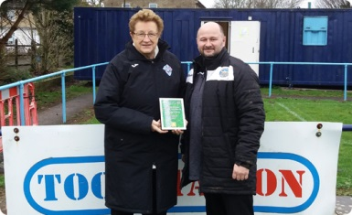

Bradford Town manager Wayne Thorne is presented with the Premier Division Team of the Month award for November by League Director Sue Merrill. Photo courtesy of Kelvin Merrill.

Upcoming Fixtures
Tuesday 7th January 2020
Premier Division
Bridgwater Town vs Cadbury Heath 19:45KO
Bridport vs Wellington 19:45KO
Keynsham Town vs Plymouth Parkway 19:45KO
Street vs Odd Down 19:30KO
First Division
Bishop Sutton vs Warminster Town 19:30KO
Welton Rovers vs Oldland Abbotonians 19:30KO
Les Phillips Cup – Second Round
Cheddar vs Cribbs 19:45KO
Shepton Mallet vs Exmouth Town 19:30KO
Wednesday 8th January 2020
Les Phillips Cup – Second Round
Tavistock vs Clevedon Town 19:30KO
GFA Challenge Trophy – Second Round
Bristol Telephones vs Brimscombe & Thrupp 19:45KO
Hallen vs Longlevens 19:45KO
Oldland Abbotonians vs Quedgeley Wanderers 19:45KO
Saturday 11th January 2020 (KICK OFF AT 3.00PM UNLESS NOTED)
FA Vase – Fourth Round
Bitton vs Warminster Town
Buckland Athletic vs Bradford Town
Woodbridge Town vs Plymouth Parkway
Premier Division
Bridgwater Town vs Shepton Mallet
Bridport vs Tavistock
Brislington vs Clevedon Town
Chipping Sodbury Town vs Wellington
Cribbs vs Street
Exmouth Town vs Roman Glass St George
Odd Down vs Westbury United
First Division
Almondsbury vs Wincanton Town
Ashton & Backwell United vs Devizes Town
Bishops Lydeard vs Longwell Green Sports
Hengrove Athletic vs Bishop Sutton
Oldland Abbotonians vs Calne Town
Portishead Town vs Wells City
Radstock Town vs Lebeq United
Sherborne Town vs Corsham Town
Welton Rovers vs Cheddar

League Tables
Premier Division
 |  | P | W | D | L | F | A | GD | PTS
1 | Bradford Town | 18 | 15 | 1 | 2 | 54 | 18 | 36 | 46
2 | Plymouth Parkway | 17 | 14 | 1 | 2 | 64 | 19 | 45 | 43
3 | Exmouth Town | 16 | 13 | 1 | 2 | 42 | 13 | 29 | 40
4 | Hallen | 20 | 12 | 3 | 5 | 44 | 33 | 11 | 39
5 | Clevedon Town | 22 | 12 | 3 | 7 | 48 | 41 | 7 | 39
6 | Shepton Mallet | 19 | 11 | 3 | 5 | 46 | 26 | 20 | 36
7 | Tavistock | 16 | 11 | 2 | 3 | 45 | 23 | 22 | 35
8 | Bridgwater Town | 19 | 10 | 4 | 5 | 50 | 30 | 20 | 34
9 | Bitton | 18 | 10 | 1 | 7 | 47 | 30 | 17 | 31
10 | Buckland Athletic | 18 | 9 | 1 | 8 | 34 | 35 | -1 | 28
11 | Street | 23 | 8 | 4 | 11 | 49 | 53 | -4 | 28
12 | Westbury United | 21 | 8 | 3 | 10 | 38 | 33 | 6 | 27
13 | Brislington | 22 | 8 | 3 | 11 | 32 | 54 | -22 | 27
14 | Keynsham Town | 20 | 7 | 3 | 10 | 37 | 44 | -7 | 24
15 | Cribbs | 20 | 7 | 2 | 11 | 31 | 48 | -17 | 23
16 | Cadbury Heath | 22 | 5 | 7 | 10 | 29 | 48 | -19 | 22
17 | Roman Glass St George | 18 | 6 | 3 | 9 | 39 | 26 | 13 | 21
18 | Bridport | 21 | 4 | 1 | 16 | 27 | 70 | -43 | 13
19 | Chipping Sodbury Town | 21 | 4 | 1 | 16 | 25 | 69 | -44 | 13
20 | Wellington | 20 | 3 | 2 | 15 | 21 | 54 | -33 | 11
21 | Odd Down | 19 | 3 | 1 | 15 | 16 | 51 | -35 | 10

First Division
 |  | P | W | D | L | F | A | GD | PTS
1 | Longwell Green Sports | 18 | 12 | 2 | 4 | 48 | 28 | 20 | 38
2 | Calne Town | 17 | 11 | 2 | 4 | 29 | 12 | 17 | 35
3 | Wells City | 17 | 10 | 4 | 3 | 42 | 21 | 21 | 34
4 | Radstock Town | 16 | 11 | 1 | 4 | 44 | 24 | 20 | 34
5 | Sherborne Town | 18 | 11 | 1 | 6 | 41 | 30 | 11 | 34
6 | Ashton & Backwell United | 18 | 9 | 5 | 4 | 31 | 33 | -2 | 32
7 | Corsham Town | 19 | 9 | 2 | 8 | 32 | 42 | -10 | 29
8 | Cheddar | 18 | 8 | 4 | 6 | 33 | 28 | 5 | 28
9 | Wincanton Town | 15 | 8 | 2 | 5 | 30 | 32 | -2 | 26
10 | Oldland Abbotonians | 17 | 7 | 5 | 5 | 22 | 26 | -4 | 26
11 | Warminster Town | 18 | 8 | 0 | 10 | 34 | 25 | 9 | 24
12 | Lebeq United | 18 | 8 | 0 | 10 | 39 | 40 | -1 | 24
13 | Bishops Lydeard | 16 | 7 | 2 | 7 | 37 | 29 | 8 | 23
14 | Almondsbury | 17 | 5 | 4 | 8 | 24 | 30 | -6 | 19
15 | Welton Rovers | 19 | 5 | 4 | 10 | 21 | 37 | -16 | 19
16 | Hengrove Athletic | 18 | 5 | 4 | 9 | 10 | 37 | -27 | 19
17 | Portishead Town | 17 | 5 | 3 | 9 | 33 | 34 | -1 | 18
18 | Devizes Town | 17 | 3 | 5 | 9 | 29 | 37 | -8 | 14
19 | Bishop Sutton | 16 | 3 | 2 | 11 | 21 | 32 | -11 | 11
20 | Bristol Telephones | 19 | 2 | 2 | 15 | 28 | 51 | -23 | 8

